**ADVANCE PROGRAMMING LAB-1**

**PROJECT**

**Title-Insurance Policy Detail System**

**Submitted to- Enroll no.-151265**

**Dr. Mahesh Kumar Name-Ayush Jain**

Discription about project-

Firstly,when you open project first window wil comes-up which has all information about student like- enrol no.,name ,batch,contact,branch, email id.With an ‘OK’ button and an information to press ‘**OK**’ button to open project.

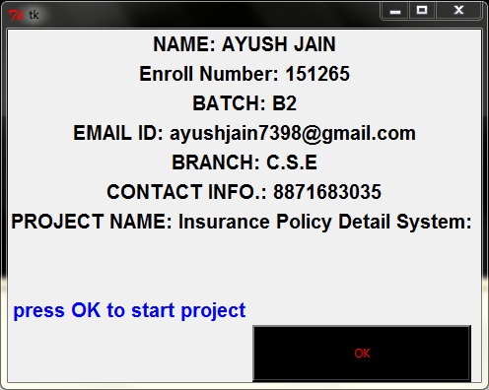

After pressing ‘**OK**’ button the main project window will appear with an title-‘**INSURANCE POLICY DETAIL SYSTEM**’,beyond this title an heading is there ‘**Types of policy**’ in it there are some policy with policy code and name and given. Like ‘151266:jeevan amrit’.

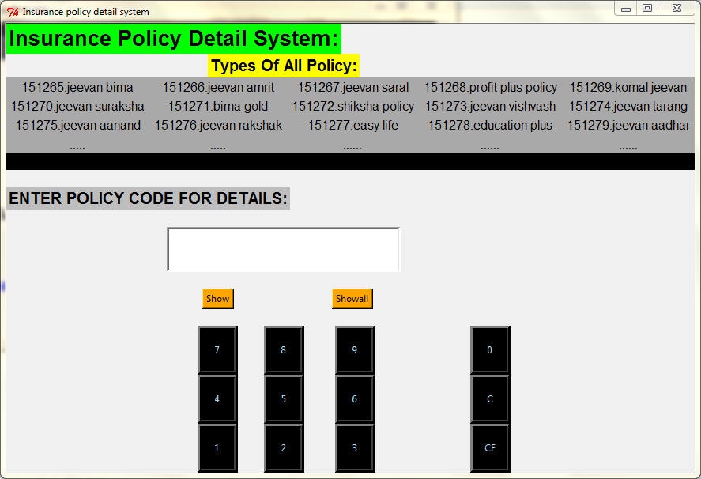

-In this window heading and an entry box is there in which we enter the policy code to get information about policy. For this we also having buttons in this window to enter the code of particular policy you want know about.

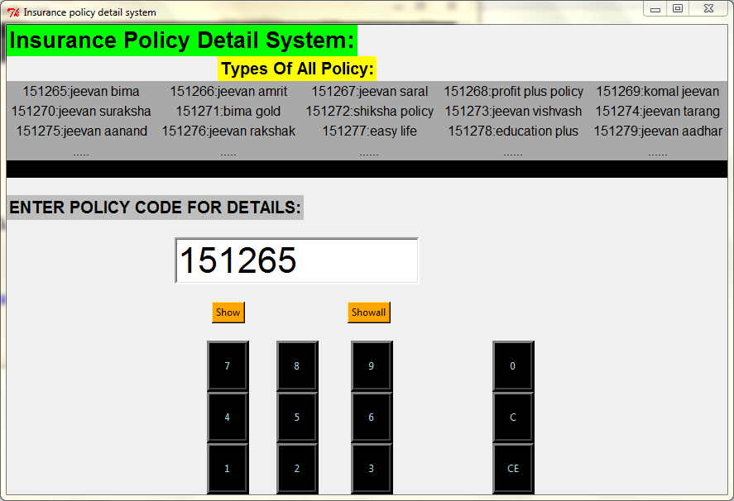

Now you enter code with the use of number button ,and two more button is given on right side to clear last entry “**C**” button is there and ‘**CE**’ button is to help you if wrong no. entered

Like-

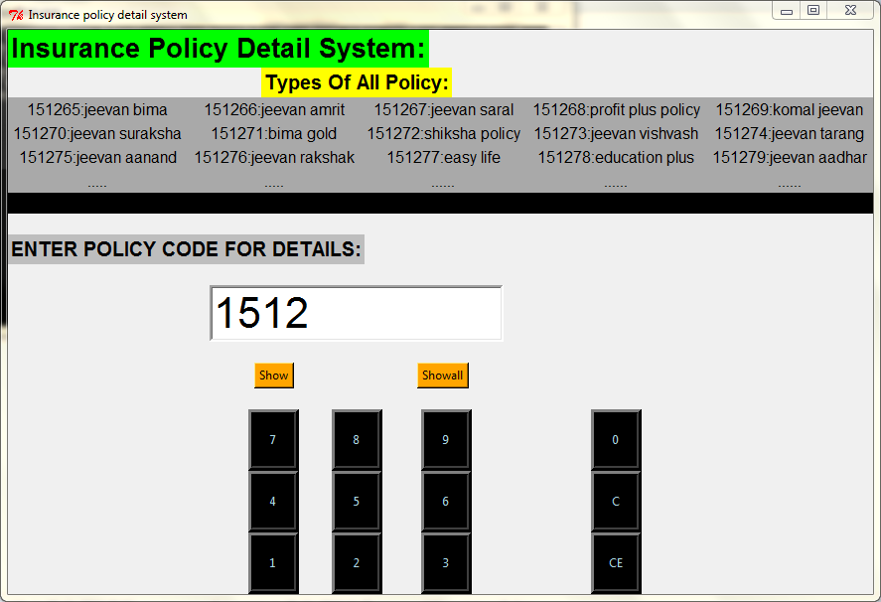

When you enter a code and click in **‘show’** button then a window with information of particular policy will appear . Like-if enter ‘151265’ code

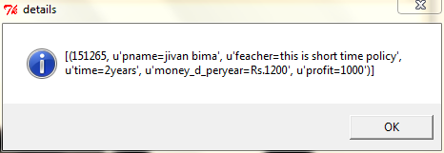

If enter 151277-

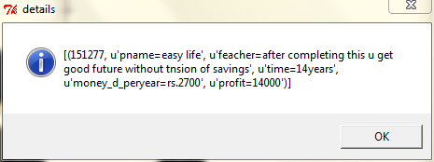

-If we want all information about all the policies stores in database we can click on ‘**show all button’** given in main project window.

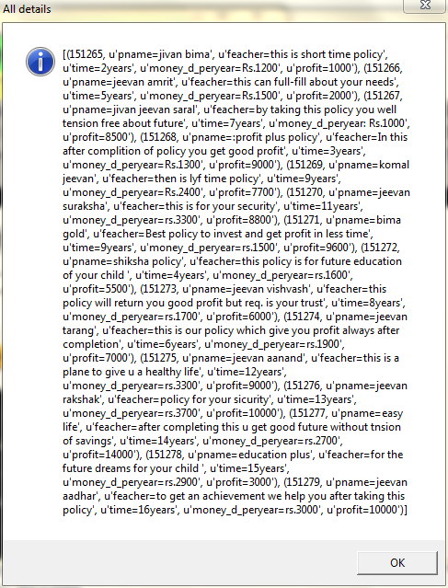

Then after click ‘OK’ button we reach on main window.

**THANK YOU**